To watch a video in CIS:

* Get headphones from the box
* Complete the following:

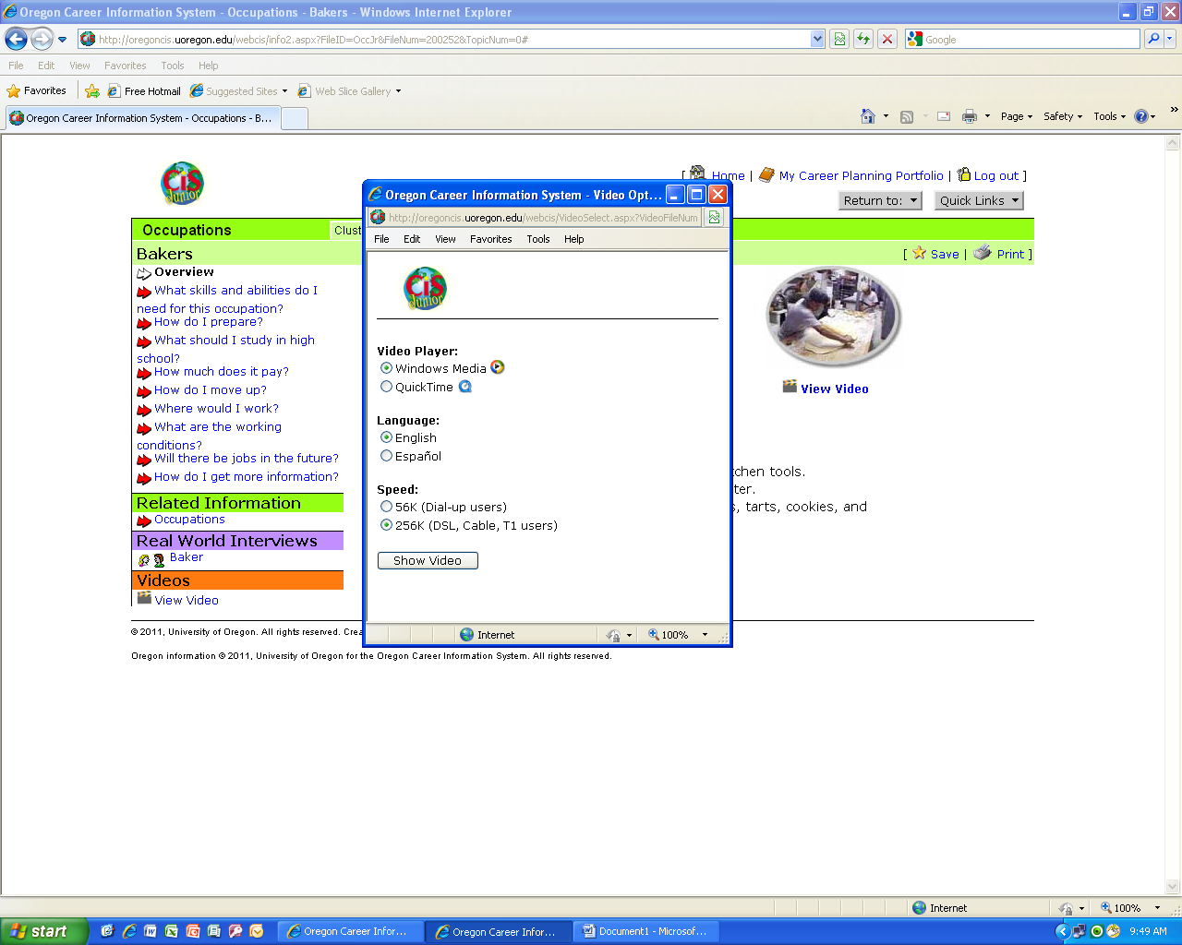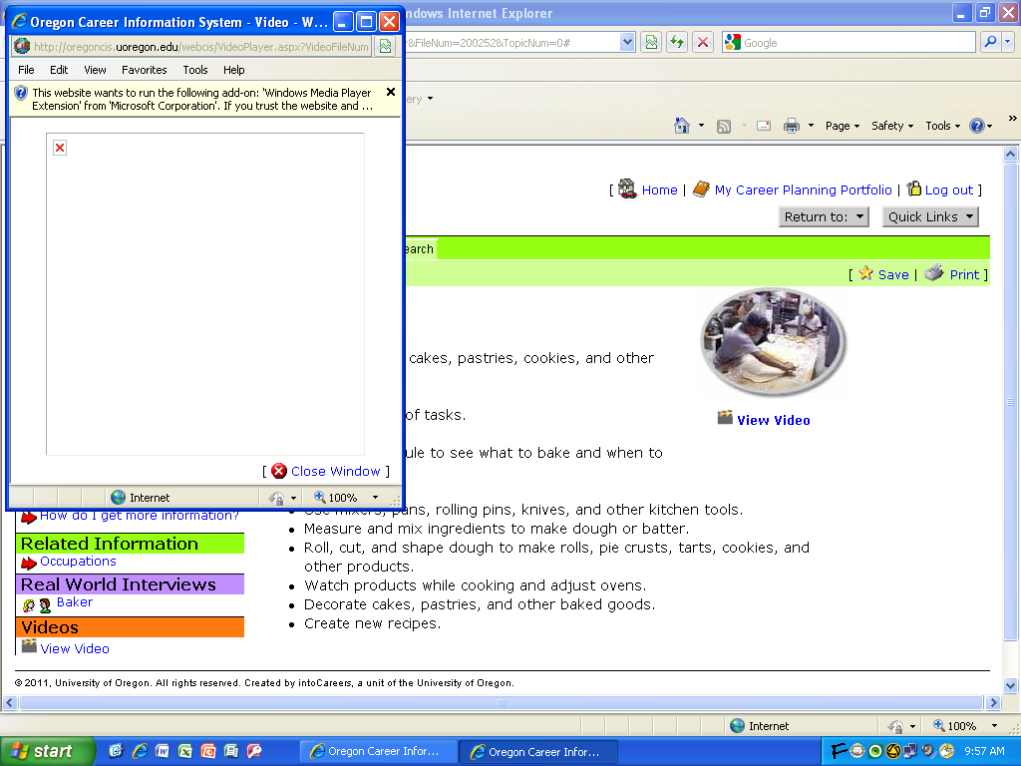

Finally, click on the yellow tab at the top of the screen and click

“run add-on” to allow the video to play: