C:\Users\koeby.johnson\AppData\Local\Microsoft\Windows\Temporary Internet Files\Content.IE5\OD64IV2G\dglxasset[1].aspxC:\Users\koeby.johnson\AppData\Local\Microsoft\Windows\Temporary Internet Files\Content.IE5\P46XDB60\dglxasset[1].aspx[](http://upload.wikimedia.org/wikipedia/commons/8/87/Christian_cross.svg)[](http://en.wikipedia.org/wiki/Hinduism)[](http://en.wikipedia.org/wiki/Dharmacakra)**World Religions Project**

Classroom Discussion

* What do you think is the meaning of each of the two following quotes?
* Do you agree or disagree with each quote? Why?

***"Every religion is good that teaches man to be good."***

Thomas Paine, 1737-1809, early American patriot.

***"A zeal for different opinions concerning religion, concerning government, and many other points......have, in turn, divided mankind into parties, inflamed them with mutual animosity, and rendered them much more disposed to vex and oppress each other than to cooperate for their common good."***

James Madison, 1751-1836, early American patriot, from the *Federalist Papers* of 1787.

Most of the people on Earth live with other people in some sort of organized culture. There are a number of traits in those cultures that meet the basic needs of the people such as food, shelter, clothing, education, traditions, government, economics, family life, and, of course, religion.

For thousands of years, religion has been a very major part of culture, influencing governments, families, daily habits, and more. For example: Christians risked their lives to practice their faith during the Roman Empire; Jews and Muslims are forbidden to eat pork; the Qu’ran is the foundation of civil law in Saudi Arabia; conflict can erupt when people feel their religion is threatened as seen in the fighting in Sri Lanka between the Buddhist Sinhalese and the Hindu Tamils. Religion can also provide a code of behavior in a person's relationship with other people. For example, almost every major religion promotes a tenet resembling the Golden Rule of "doing unto others as you would have them do unto you."

* Part A – The Poster!

This poster will teach the class about one major world religion, in both a textual and visual format, providing an opportunity to compare and contrast these important belief systems.

The major world religions to be researched in this activity will be:

**Christianity, Islam, Hinduism, Buddhism, Judaism, Taoism, Shinto, Confucianism,** and **Animism/Ethno/Primal Indigenous Religions**.

Students will work in small groups to study one religion (circle your assigned topic above).

Use library books and the GoogleDocs Research to research the following information:

* Basic beliefs and rules of the religion

___________________________________________________________________

___________________________________________________________________

___________________________________________________________________

___________________________________________________________________

___________________________________________________________________

___________________________________________________________________

___________________________________________________________________

___________________________________________________________________

___________________________________________________________________

___________________________________________________________________

___________________________________________________________________

___________________________________________________________________

* Major symbols, texts (books), holidays, traditions and holy sites

___________________________________________________________________

___________________________________________________________________

___________________________________________________________________

___________________________________________________________________

___________________________________________________________________

* Founder(s)/Leader(s)/Prophets/Deities/

___________________________________________________________________

___________________________________________________________________

_________________________________________________________________________________________________________________________________________________________________________________________________________

* Date(s) of origin

___________________________________________________________________

___________________________________________________________________

* Major parts of the world where it is practiced today

___________________________________________________________________

___________________________________________________________________

___________________________________________________________________

* How it spread and number of followers today

___________________________________________________________________

___________________________________________________________________

___________________________________________________________________

___________________________________________________________________

At least four sources of information for your Works Consulted, two books required.

1. _________________________________________________________________________________________________________________________________________________________________________________________________________
2. _________________________________________________________________________________________________________________________________________________________________________________________________________
3. _________________________________________________________________________________________________________________________________________________________________________________________________________
4. _________________________________________________________________________________________________________________________________________________________________________________________________________
5. _________________________________________________________________________________________________________________________________________________________________________________________________________

After all of this information has been collected, each group will design a poster that will present the material visually. The poster should be designed to help classmates learn about the religion. Make it a dazzling display of your graphic design skills!

The poster should include:

* Multiple visual symbols and illustrations for the religion (such as a cross for Christianity, the Bodhi Tree for Buddhism, or the Om symbol for Hinduism)
* Text (in your own words – not plagiarized!)to explain the basics of the religion: beliefs, rules, books, traditions, holidays, holy sites…and anything surprising or interesting that your classmates should know
* A picture of the founder/important leaders/main deities/prophets
* Dates of the origin of the religion
* A world map showing where in the world this is the main religion today
* Works Consulted showing your sources of information (use EasyBib!)
* Part B – Three Religions Table & Triple Venn Diagram!

Once the posters are finished, they will be displayed at tables around the classroom. Students will move around the classroom, reading posters and taking notes on three religions, using the **Three Religions Table**. Write as much as you can, so that you have as much information as possible for MASTERY LEVEL **Triple Venn Diagram**!

|  |  |  |  |  |  |  |
| --- | --- | --- | --- | --- | --- | --- |
| **Standard** | **Learning Target** | **Mastery** | **Proficient** | **Approaching** | **Developing** | **Beginning** |
| **Historical Knowledge**  **7.1** | **I can describe three beliefs of major world religions.**  **(Knowledge)** | -Lists three major religions and three of their main beliefs along with their major founders with historical details. | -Lists three main beliefs of several major religions with some detail about the founders. | -Lists several ideas about two major religions. | -Describes some ideas about one major religion. | -Unable to determine level of proficiency due to lack of evidence. |
| **Historical Knowledge**  **7.1** | **I can explain how major world religions spread.**  **(Reasoning)** | -Clearly explains how three major religions spread; may include references to infrastructure, and the influences of historical figures and preexisting religions. | - Clearly explains how three major religions spread and shows connections between the religions. | -Explains how two major religions spread. | -Explains how one religion spread; may include some errors. | -Unable to determine level of proficiency due to lack of evidence. |
| **Historical Knowledge**  **7.1** | **I can compare and contrast major world religions.**  **(Reasoning)** | -Thoroughly compares and contrasts the beliefs and rituals of three major religions and how they affected each other. | -Compares and contrasts the beliefs and rituals of two major religions. | -Compares and contrasts in a general manner the beliefs and rituals of two major religions with some errors and omissions. | -Compares a few ideas and events involving two major religions with some errors and omissions. | -Unable to determine level of proficiency due to lack of evidence. |

|  |  |
| --- | --- |
| **Three Religions Table** | |
| Name of Religion |  |  |  |
| Three main beliefs |  |  |  |
| Founders/leaders/  prophets/important gods |  |  |  |
| Date(s) of origin |  |  |  |
| Special holidays or celebrations |  |  |  |
| Where/how it spread |  |  |  |

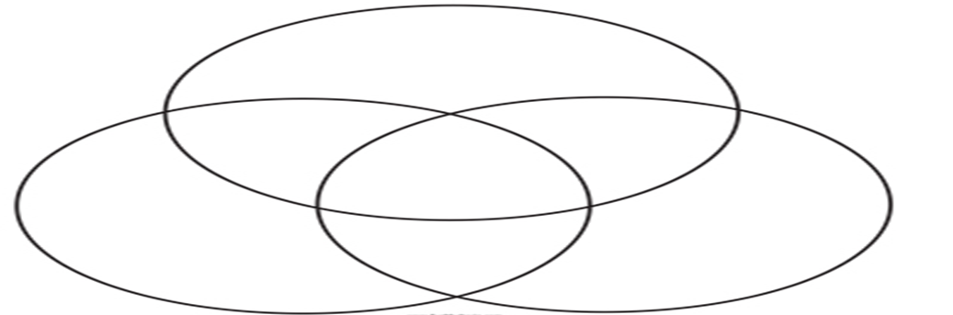

Triple

Venn

Diagram