## SCORING GUIDE FOR CURRENT EVENTS Name: ____________________________________ Date:___________ Period: ____

|  |  |  |  |  |  |  |
| --- | --- | --- | --- | --- | --- | --- |
| **Standard** | **Learning Target** | **Mastery** | **Advanced** | **Meets** | **Approaching** | **Beginning** |
| **RST.7.2**  **Determine the central ideas or conclusions of a text** | **I can compose a summary stating the key information, central idea, or conclusions of the text without adding my own prior knowledge or opinions (Product)** | -Summarizes the who, what, when, where, why and how in a coherent, detailed way, including what caused the incident and its potential impact on the people, place, region, world.  -Cause and effect clearly stated with two distinct sentences. | -Summarizes the who, what, when, where, why and how in a coherent way, including what caused the incident and its potential impact on the people, place, region, world.  -Cause and effect are clear. | -Summary is mostly complete, but might be missing some facts.  -Cause and effect are stated, but might be a little unclear. | -Summary contains words taken too much from the article—not in your own words.  -Cause and effect may not be present. | -Unable to determine level of proficiency due to lack of evidence. |
| **WHST.7.9**  **Draw evidence from informational texts to support analysis reflection, and research.** | **I can compose written responses and include evidence to support my analysis and reflection (Product)** | -Includes a realistic prediction, based on the facts in the article, about what might happen next  -Includes a thoughtful personal reflection/reaction e.g. your opinions, feelings, possible personal or family connection, global significance.  -Connects the event to another very relevant event. | -Includes a prediction, based on the facts in the article, about what might happen next.  -Includes a personal reflection/reaction e.g. your opinions, feelings, possible personal or family connection, global significance.  -Connects the event to another event. | -Prediction is made, but needs more details.  -Includes personal reflection/reaction but does not seem truly involved in what s/he is reporting.  -Makes an attempt to relate the event to another event, but has an unclear connection. | --Includes a prediction with incomplete facts presented or illogical thinking.  -Personal feeling lacking or seems flat.  -No clear connection to another event. | -Unable to determine level of proficiency due to lack of evidence. |
| **Geography**  **7.8** | **I can use maps to gather information, analyze geographic distributions and/or patterns, and make predictions regarding the Eastern Hemisphere.**  **(Skill)** | -Identifies cardinal directions with complete compass rose  -Includes very detailed map with all surrounding countries and important bodies of water and mountains, if any. | -Identifies cardinal directions with compass rose  -Includes map with surrounding countries and important bodies of water and mountains, if any. | -Has compass rose.  -Includes map with most surrounding countries and important bodies of water and mountains, if any. | -Incompletely identifies location.  -Map may be included but is not labeled or lacks surrounding countries and water bodies. | -Unable to determine level of proficiency due to lack of evidence. |
| **WHST.7.8**  **Quote or paraphrase the data and conclusions of others while avoiding plagiarism and following a standard format for citation.** | **I can follow a standard format for citation to create a bibliography for sources paraphrased or quoted in my writing (Knowledge)** | -Correctly cites source, with no errors, from an appropriate online news source or newspaper.  -Article attached. | -Correctly cites source, with few errors, from an appropriate newspaper or online source.  -Article attached. | Cites source, with numerous errors, from an appropriate newspaper or online source.  -Article attached. | -Source is cited incorrectly or incompletely.  -Article not attached. | -Unable to determine level of proficiency due to lack of evidence |

MLA formatting: Times New Roman or Arial 12.

**SOCIAL SCIENCE: CURRENT EVENTS**

**Find an article about the country from a newspaper or online news source:**

[**BBC World News**](http://www.bbc.com/news/)[**National Geographic News**](http://education.nationalgeographic.com/education/reference-and-news/?ar_a=1)[**Time for Kids**](http://www.timeforkids.com/search/site/kenya)[**Time Magazine**](http://www.time.com)[**CNN News**](http://www.cnn.com/WORLD/?hpt=sitenav)[**ABC World News**](http://abcnews.go.com/international)

[**Google News**](https://www.google.com/?gws_rd=ssl#q=news&tbm=nws)

**Try to find an article from the past few weeks or months; you can choose an older article if necessary. Read it carefully. Print a copy of the article to attach to this assignment. Then write a summary and personal reflection.**

_____ Write your name, date and period in the upper right hand corner.

_____ Write the title of the article centered on the page.

**Requirements: two paragraphs and a hand-drawn or hand-labeled map**

Blank outline maps can be found here: [worldatlas.com](http://www.worldatlas.com/webimage/testmaps/maps.htm)

_____ Include a hand-drawn or hand-labeled map which shows **your nation and the surrounding countries**, and important bodies of water and mountains, if any. Include a compass rose. Put this map in the upper ¼ of your paper. ***Color the map!***

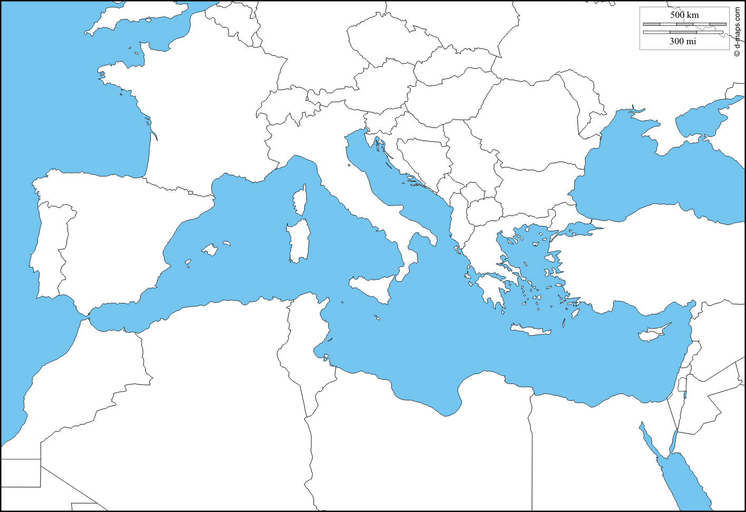

**Paragraph One:**

_____ Write a clear summary covering *who, what, when, where, why and how* about the event.

_____ Write at least two sentences about the cause and the effect of the event.

**Paragraph Two:**

_____ Write your personal reaction to the event. (How do you FEEL about it?)

_____ Make a connection between this event and something else you know about.

_____ Make a prediction about what will happen next.

_____ Cite the source of the article at the bottom. Use MLA formatting (EasyBib.com); for example:

Smith, Jane. "Impact Your World." *CNN*. Cable News Network, 20 May 2014. Web. 20 May 2014. <http://www.cnn.com/SPECIALS/impact.your.world/>.

**CURRENT EVENTS SUMMARY ‘GIST’ TEMPLATE**

|  |  |  |  |
| --- | --- | --- | --- |
| WHO | 15 KEY WORDS FROM ARTICLE | | |
| WHAT |  |  |  |
| WHERE |  |  |  |
| WHEN |  |  |  |
| WHY |  |  |  |
| HOW |  |  |  |

**SUMMARIZE THE CAUSE AND EFFECT IN TWO SENTENCES:**

__________________________________________________________________________________________________________________________________________________________________________________________________________________________________________________________________________________________________________________________________________________________________________________________________________________________

**HOW TO APPROACH YOUR ARTICLE AND SUMMARY**

**Questions to consider as you read and prepare to summarize your article:**

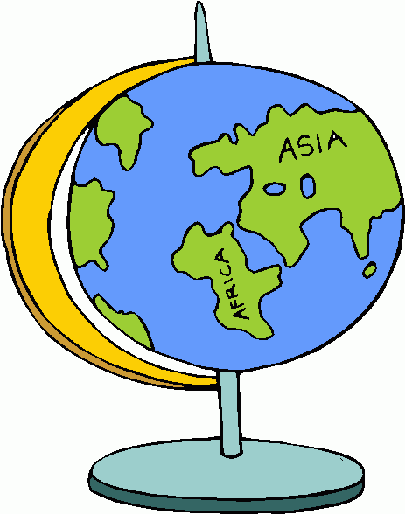

* What is the main idea (subject/topic)?
* Where is it happening?
* Who is giving the information?
* Is the situation/event/product a problem or solution? If so what?

**Things that you should strongly consider as you prepare your thoughts:**

* Is it about a natural disaster?
* Is it typical or atypical in general or for the area?
* Would it be different if it occurred in the US instead of the Eastern Hemisphere?
* How does it affect/impact you?
* Might it impact you in the future? Directly or indirectly?
* Does it prompt you to change, react, or be concerned?

**Composition Components (things to consider as you write):**

* Be conscious of the number of facts you need to add. Are you adding enough details? What facts support or contribute to the situation?
* Are you adding relevant details?
* Does your follow-up personal reaction incorporate your existing knowledge and build on what you have learned from the article?