TEAM 7.1 Social Science.
DECORATE THE COVER OF YOUR COMP BOOK.
SUPPLIES NEEDED:
- Glue stick.
- Cut out images from newspapers, magazines and/or from color printouts from the internet.
- Optional: clear shipping/packaging tape to cover it

- Pictures and graphics should be of fascinating and captivating places from around the world, e.g., buildings, bridges, monuments, landscapes, inventions, modes of transportation.

- These images should be from the Eastern Hemisphere.

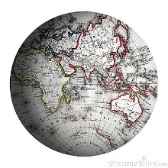
- The cover should look like a visual travel journal.

- Include your Name, Period Number and Social Science on the cover.

- A hand-written quote about travel or world history would also be appreciated.
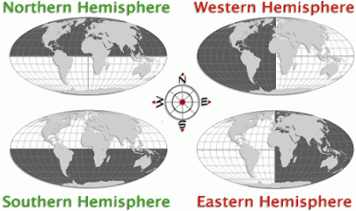

“We travel not to escape life, but for life not to escape us.”--Anonymous

“I don’t know where I’m going, but I’m on my way.”—Carl Sagan

