In the Footsteps of Alexander the Great

Name ____________________________________________

Date ____________________________ Period _________
Film Notes

- Take notes on 3 (or more) INTERESTING facts you didn't already know about the life of Alexander the Great: (use the back if necessary)
a.
b.
c.
- What is one location in the film that you would like to visit for yourself?

- Read the biography of Michael Wood, the filmmaker of In the Footsteps of Alexander the Great.

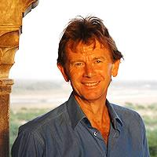
Michael Wood
For more than 20 years, historian and broadcaster Michael Wood has made compelling journeys into the past, which have brought history alive for a generation of readers and viewers. He is the author of several highly praised books on English history including In Search of the Dark Ages, The Domesday Quest, in Search of England and In Search of Shakespeare. He has over 80 documentary films to his name, among them Art of the Western World, Legacy, In the Footsteps of Alexander the Great, Conquistadors and In Search of Myths and Heroes. His most recent work is the epic 6 part television series The Story of India which aired on BBC2 in August 2007. Michael was born in Manchester and educated at Manchester Grammar School and Oriel College Oxford, where he did post-graduate research in Anglo-Saxon history. He is a Fellow of the Royal Historical Society.

Based on this biography, is Wood a credible, trustworthy source of information? Why or why not?

- How has the film changed or supported your opinion of Alexander?

- What is a question you have after seeing the film? What do you want to know more about?

