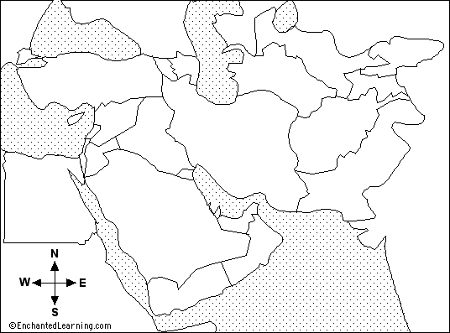

LABEL THE COUNTRIES AND BODIES OF WATER ON THE MAP

