Montenegro Albania Greece Turkey Cyprus Syria Israel
Lebanon Egypt Libya Malta Tunisia Algeria Morocco
Bosnia-Herzegovina
Spain France Monaco Italy Slovenia Croatia
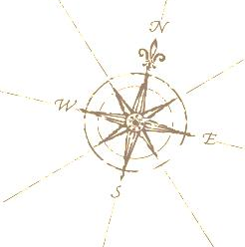
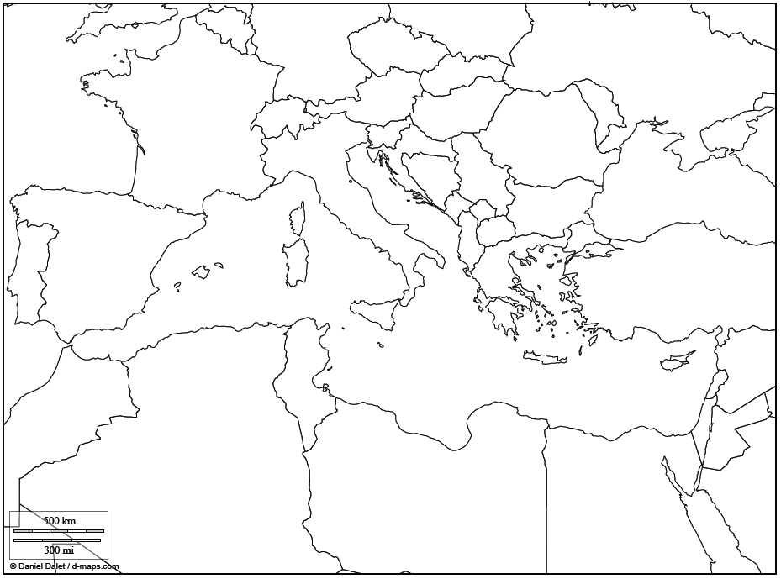
Name: ________________________ Date:________ Per:_____APP:___________
MEDITERRANEAN MAP TEST
This map shows the nations which border the Mediterranean Sea. Carefully label each country that bordes the Mediterranean Sea. There are 21. Use the list on the back to help you spell them. Label the following seas and ocean: Mediterranean Sea, Black Sea, Red Sea, Adriatic Sea, Aegean Sea, and Atlantic Ocean.

