SUSTAINABILITY
TAPPED DOCUMENTARY Name:___________________ Period:_____
Geography
7.14. I can explain how technological developments, societal decisions, and personal practices influence sustainability in the Eastern Hemisphere.
Economics/Financial Literacy
7.22. I can explain the concepts of supply and demand and how price allocates scarce goods. I can perform a cost/benefit analysis. I can explain the function of profit in the economy.

VOCABULARY:
municipal - refers to city or town. Municipal water is tap water—paid for with tax dollars.
gyre: a in oceanography is any large system of rotating ocean currents, particularly those involved with large wind movements.
contamination - In food chemistry and medicinal chemistry, the term "contamination" is used to describe harmful intrusions, such as the presence of toxins (poisons) or pathogens (germs).
lobbying - the act of attempting to influence decisions made by officials in the government, most often legislators or members of regulatory agencies.
commodity: a raw material or primary agricultural product that can be bought and sold, such as copper or coffee
supply – the amount of a product which is available to customers
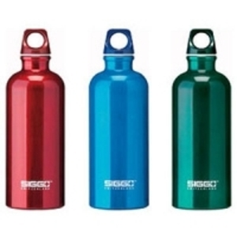
demand – the amount of a product people are willing to buy at a certain price

- In Freyberg Maine, which corporation is taking the town’s water?

- What is the brand name of the bottled water?

- In February of 2004, what happened in the town?

- Nestle’s water sales were ____________ billion dollars.

- ______ percent of earth is water. Of our water on earth, what percent of this is drinkable, (potable)? _________

- What is Absolute Dominion? Did Nestle notify the residents of the town before taking their water or pay the town anything?

- Write the Gandhi quote on water:

- The World Bank places the world water market value at _____________________ billion dollars.

- In 2007, there was a drought in how many US states?
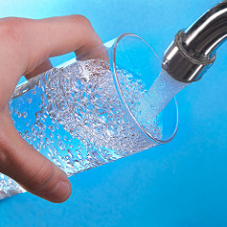

- Aquafina, Dasani among others are simply _______ water.

- ____% of bottled water is from public supplies of municipal tap water.

- In 2007, how many billions of dollars were spent on bottled water?

- ____% of PET ends up in Coke, Pepsi or Nestle water containers.

- Where is the largest oil refinery in the US? What does this have to do with bottled water?

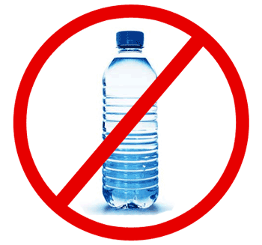
- How many gallons of oil are used to make plastic bottles each year?

- Suzie Canales, director of Citizens for Environmental Justice lost her sister to cancer. What does she think is a cause?

- What are some of the health concerns for people in Corpus Christi, Texas, the home of the largest oil refinery and bottle manufacturer?

- How many employees are responsible for testing bottled water at the national level?

- True or false: If bottled water is bottled in the state and does not cross state lines to be sold, it does not have to be tested for safety.

- Are the bottle water companies required to submit a regular report to the FDA (Food and Drug Administration)?

- Have there been recalls of bottled water because of contamination?

- A city of 3 million has to test their city tap water ______________ times a month.

- What happened to the water samples that were left in the trunk of the car?

- What is Toluene?

- BPA Bisphenol A is found in the 5-gallon water bottles. It acts an estrogen (hormone) in the human body. Name three conditions or diseases that this is linked to:

- Of the 80 million bottles a day consumed in the US day, ______________ end up in landfills.

- What percent of beverage containers are recycled in the US?

- How many states have bottle bills? How many include bottled water? Does Oregon have a bottle bill?

- The bottled water industry says 100% of water bottles are recyclable. But, what percentage of people in the US don’t have access to curbside recycling?

- What’s the name of the scientist studying plastic in the oceans?
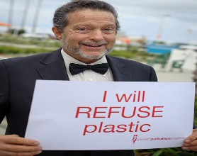

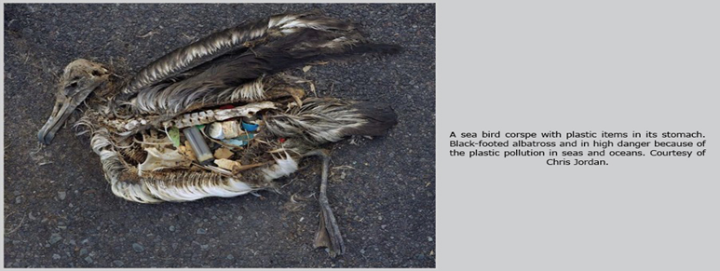
- The Eastern Pacific Garbage Patch is approximately how big?

- _____times as much plastic as plankton are found in the ocean in the last survey
in 2008.

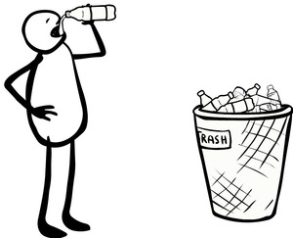
Here, write down, thoughts, feelings, reactions, other questions you have about this issue. (I WONDER…, THIS MAKES ME FEEL…, WHAT ABOUT…? WHY NOT…?)

____________________________________________________________________________________________________________________________________________________________________________________________________________________________________________________________________________________________________________________________________________________________________________________________________________________________________________________________________________________________________________________________________________________________________________________________________________________________________________________________________________________________________________________________________________________________________________________________________________________________________
____________________________________________________________________________________________________________________________________

