THE RISE OF ISLAM STUDY GUIDE
Name:___________________ Date:______ Per:_________APP: ________

 | caliph |  | Ottoman Empire
 | Muhammed |  | Sunnis
 | Omar Khayyam |  | Hijrah
 | oasis |  | Makkah
 | Indonesia |  | mosque

 | Islam |  | muezzin
 | Al-Razi |  | minarets
 | Qu’ran |  | Muslims
 | Timbuktu |  | Five Pillars of Islam
 | Taj Mahal |  | Shiites

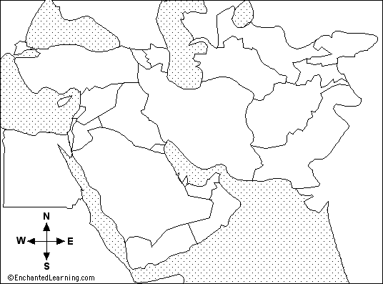
Label Mecca, Medina and any three countries

Why does Islamic art and architecture feature arabesques and flowers and stars, but no images of Muhammed or other human figures?

What is the Hijra When was the Hijra? Why is that date important?

Name three contributions of the Muslims to modern science, math, or medicine:

Name the five pillars of Islam (in English).

About how many people visit Mecca, Saudi Arabia for the Hajj?

What is the pilgrimage site with the big black building called in Mecca?

What three places did the pilgrims come from in the documentary, Inside Mecca?

_________ – the religion of the Muslim people, meaning “surrendering to the will of God”
________________ – founder and prophet of the Islamic faith, born in 570 CE
____________– the Muslim word for God
____________ – largest and richest town on the Arab trade routes, holiest city for Muslims
_______________ – Muslim house of worship, also serves as a school and a court
____________ – law code from the Muslim holy books, gives rules for how society should be run
__________ and_________________ – two main branches of the Muslim religion
_______________ – people who trace their ancestors to Arabia, or whose first language is Arabic
______________ – the holy book for Muslims
____________ – ‘holy’ wars declared by the Christian Pope against Muslims in Jerusalem
____________– open marketplace in a Muslim city
______________ – a group of merchants and animals, traveling together for safety
______________ – a green area in the desert fed by underground water
_____________ – best known Muslim chemist who classified things according animal, mineral, or vegetable; wrote many books on disease
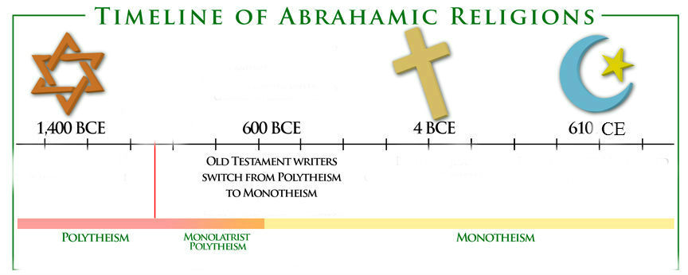
_______________ – great historian who understood the connection between geography, climate, and history

