Three Religions Table
Name of Religion
Three main beliefs
Founders/leaders/
prophets/important gods

Date(s) of origin
Special holidays or celebrations
Where/how it spread

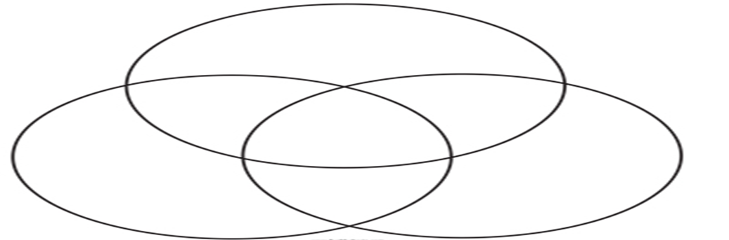
Triple
Venn
Diagram

